CREATING YOUR THESIS POSTER

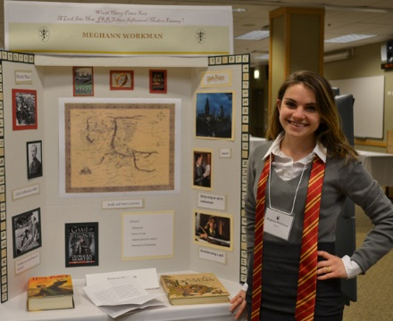

You are required to complete a thesis poster to complement your written thesis. The poster will display your research or creative work, providing viewers with a visual representation to help them conceptualize the topic, background information, research or creative process, and findings of the thesis project. You are free to utilize a combination of text and visuals (artistic and/or quantitative graphics) to inform viewers of the results of your thesis process.

You will use your poster when you present your thesis at the Honors Student Conference on May 10, 2019. There will also be a viewing session at the conference when you will stand beside your poster to answer visitor questions. If you attend the Honors Senior Gala on May 11, your poster will be displayed there as well.

Please note that students graduating in November or March are still expected to present their thesis projects at the Honors Conference in May.

Display boards are available in the Honors Office (990 W. Fullerton, suite 1300) where you can also view examples of posters completed by honors graduates. Poster-sized documents up to 56” wide and 36” high may be printed free of charge in the Richardson Library and then glued or clipped to the poster board. Instead of printing your poster, you may opt to cut and paste text and visual elements directly to your display board.

For poster-printing instructions, go to the DePaul University Library website and select ServicesTechnologyPrint-Scan-CopyHow do I Print Posters? or visit http://libguides.depaul.edu/poster-printing for details.

If you would prefer a digital presentation in place of a thesis poster, please discuss your plans with Nancy (ngrossma@depaul.edu).

Please see the other side for poster guidelines.

Keep the following elements in mind as you construct your poster:

TITLE Make sure that you place the title of your work in a prominent position on your poster. You should also include your name, the name of your thesis director, and the name of your faculty reader.

SIMPLICITY The most effective posters present information in a manner that is straightforward and brief. Rather than attempting to include your entire body of work, focus on including a series of panels which present your most relevant information.

HEADINGS In order to ensure that your poster is both concise and organized, it will be very helpful to use headings such as, “Introduction”, “The Research Question”, “Findings”, etc. These specific titles may vary, but their inclusion will enable your audience to comprehend your work more quickly and will also establish a flow within your poster.

SIZE The text and graphics on your poster should be large and bold. Because this portion of your presentation is intended to convey your work in a visual manner, it is important that your audience can see it clearly. For headings, use at least a 48-point font and for body text, use nothing less than 18-point font.

COLOR AND CREATIVITY Your poster is a place to present your findings, but it is also a place to have fun, express yourself, and attract the audience to your work. Incorporate color, detail, and plenty of varied visuals. Make sure that you are also attentive to the layout and placement of your materials. Every detail counts!

CARE Your poster represents you, your thesis faculty, and the Honors Program so remember to use care when constructing it. After you have planned and organized your work, make sure that it communicates your research and/or creative work in a lively, but also accurate manner. Feel free to ask your thesis director or faculty reader to proof your work. Because this poster is intended to reach a wide audience, it may also be helpful to ask friends and family for their input, as well.

Please contact the Honors Office if you have any questions or ideas
you would like to discuss about your thesis poster.
We look forward to viewing your work at the
Honors Student Conference and Honors Senior Gala!

